Launceston Church Grammar School
21 July, 2014 – Professional Learning Day
Web page for the Day: http://workshops.tommarch.com

Goal: to Continuously Optimise Student Learning
Use the Feedback Opportunities for this and all other main points
Successful Learners…
- develop their capacity to learn and play an active role in their own learning
- have the essential skills in literacy and numeracy and are creative and productive users of technology, especially ICT, as a foundation for success in all learning areas
- are able to think deeply and logically, and obtain and evaluate evidence in a disciplined way as the result of studying fundamental disciplines
- are creative, innovative and resourceful, and are able to solve problems in ways that draw upon a range of learning areas and disciplines
- are able to plan activities independently, collaborate, work in teams and communicate ideas
- are able to make sense of their world and think about how things have become the way they are
- are on a pathway towards continued success in further education, training or employment, and acquire the skills to make informed learning and employment decisions throughout their lives
- are motivated to reach their full potential.

Knowing, Doing and Understanding

Things you “Know” | Skill you can “do” | Things you “Understand”

Transfer Goals = “Accomplishments”
From Jay McTighe:
Transfer goals have several distinguishing characteristics:
- They require application (not simply recognition or recall).
- The application occurs in new situations (not ones previously taught or encountered; i.e., the task cannot be accomplished as a result of rote ‘plugging in’).
- The transfer requires a thoughtful assessment of which prior learning applies here – i.e. some strategic thinking is required (not simply following a recipe that is insensitive to context).
- The learners must apply their learning autonomously (on their own, without teacher prompting or support).
- Transfer calls for the use of habits of mind (i.e., good judgment, self regulation, persistence) along with academic understanding, knowledge and skill.
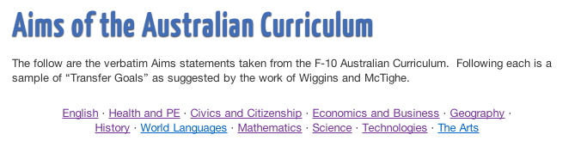
Immersion into Transfer Goals: http://tommarch.com/consulting/ubd/aims-of-the-australian-curriculum/

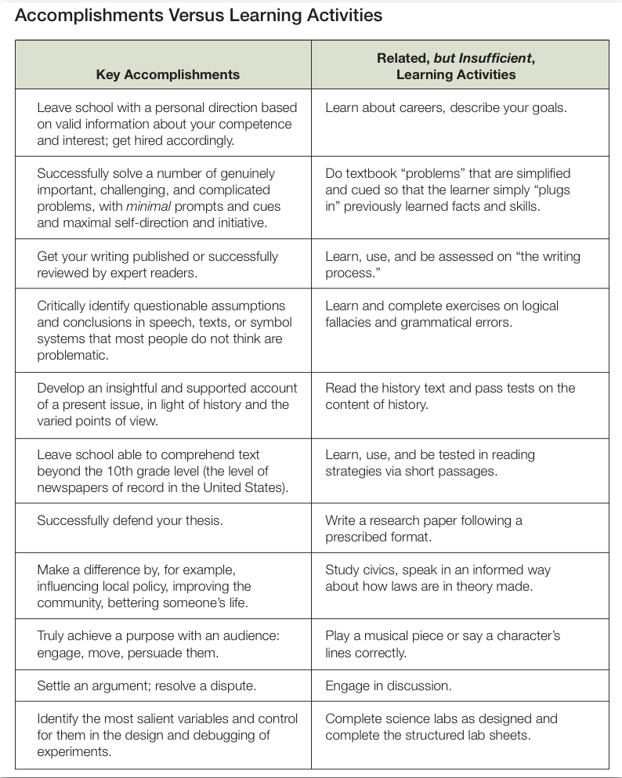

Knowledge
Skills
Understanding
Meaning
(personal value)
Direction
(personal application)

