Next Era Ed Checklist: Designing Your Version

Workshop Web site - http://workshops.tommarch.com/
- Padlet: Actions at Schools - http://padlet.com/tommarch/edtechsa2015

Vision
Does your school have a vision of student success that is aspirational and includes articulated descriptors?
- the school’s (shared)
- student success (not a teaching or school vision)
- aspirational (big goals are more motivating)
- articulated descriptors (what does it look like exactly?)
5 minute Activity: What is your school’s vision? If it’s not clear, what is it (really?)
Take Issue?
Online Resources available at http://workshops.tommarch.com

Evidence
Using backward design, does your school have a continuum of rich performance tasks that validate the vision and prompt interdisciplinary demonstrations of students' understandings that require their transfer to new contexts?
- Backward Design? (clear goals before applying solutions)
- Continuum? (allowing for individualised learning and accomplishments)
- Rich Performance Tasks (for challenges, creativity and personal meaning)
- Interdisciplinary (because the world is)
- Demonstrations (provides evidence for the vision)
- Understandings (knowledge & skills used to develop enduring conceptual learning)
- Transfer (“recall” is poor cognitive use & misaligned to the 21st Century)
5 minute Activity: Which bits do you already have?
5 minute Activity: Which others would be the easiest to add at your school?
Take Issue?
Online Resources available at http://workshops.tommarch.com

Learning Theories
Given the student performances your vision describes, what learning theories – and their research findings – are most likely to generate the desired evidence of your achievement as a school?
- What learning theories are in play at your school?
- What’s the quality of the research?
- Do the theories sync with your vision / desired evidence?
- Can you measure the effectiveness of the theories?
5 minute Activity: Share the learning theories in play at your school or what you’d like to do.
Online Resources available at http://workshops.tommarch.com

Curriculum 2.0
Are your teaching and learning practices founded on the Learning Theories and lead to student demonstrated Evidence of the Vision? Also, in an age of rich digital resources and personalised devices, are ICTs used to engage students in personally meaningful accomplishments?
- Direct links between theories and classroom practice?
- ICTs are integrated into (rich) tasks? (not just knowledge acquisition and searching)
- Do you have some model activity structures?
5 minute Activity: Describe a learning activity you like that supports your vision for student success and that uses ICTs.
Online Resources available at http://workshops.tommarch.com

Review
Do you have systemic reviews embedded that “close the loop” for continuous improvement?
- Are Curriculum / Evidence review sessions built into your school calendar?
- Do people at your school consciously seek to “close the loop” between Vision, classroom practices and Evidence of student achievement?
- Do teachers participate in action research or Professional Learning Communities?
5 minute Activity: Discuss Review processes at your school or hypothesise what could work.

(Smart Digital Environments)
Do the technology platforms or software solutions used at your school support teaching, learning, curriculum development, student learning profiles, parent access, etc.?
- What systems do you use?
- What data lives in which systems?
- Are the systems integrated (drawing from a single database)?
- Can you “connect the dots” between the systems to “close the loop”?
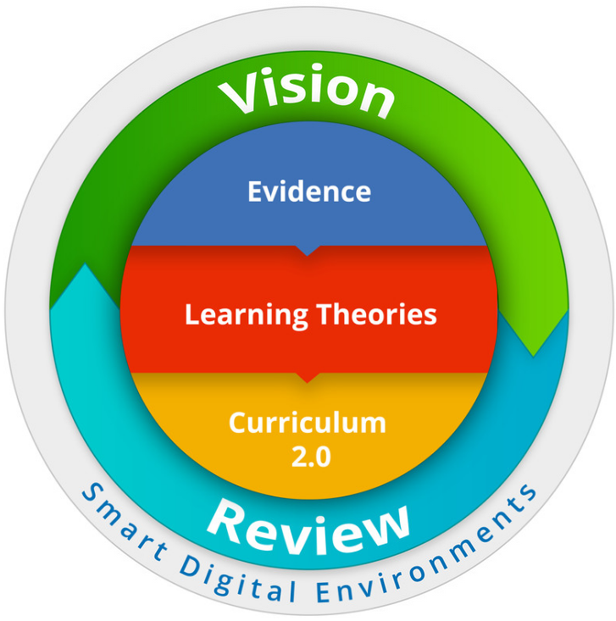

De-brief Q & A
- Looking at local issues / hurdles
- Discussing Smart Digital Environments
- Edge-ucators Way, etc.
- ???

