Aims of the College
Sacred Heart College Senior is committed to:
- The development of the whole person; ensuring all human values find unity and fulfilment in the life of the College.
- A vitality and vision which will lead to human and spiritual values being cherished.
- Helping students work towards an integration of faith and culture in day to day living.
- Providing equal access to appropriate curricula that promotes spiritual, academic, physical and emotional differences. The development of theatre, the arts and music as integral features of our religious and secular learning.
- The social development of students through careful emphasis on polite manners, suitable dress and appropriate behaviour in a variety of settings.
- Providing opportunities for students to develop a high level of personal fitness and care for their health, hygiene, and recreational interests.

TEACHING & LEARNING

To promote excellence in teaching and learning through a challenging and inclusive curriculum

School
2.1 Promote a positive culture of achievement that places teaching and learning at the forefront of all activities.
2.2 Modify and improve curriculum options that respond to changing requirements in senior secondary education.
2.3 Develop teaching methodologies that promote student centred learning, in context of creative use of information technology.
2.4 Expand the role of the Enrichment Centre to ensure students with special needs are accommodated.

Students
2.5 Provide a diverse and challenging curriculum that is inclusive of students learning styles.
2.6 Support students to develop the capacity of critical thought and independent work.
2.7 Embrace information and communication technologies that complement learning.

Staff
2.8 Provide a professional development program which is relevant, flexible and dynamic.
2.9 Encourage and support post graduate study options that increase professional knowledge and capacity.
2.10 Review learning area alignments in context of the new SACE.
2.11 Provide a range of opportunities for students to demonstrate success, across and within the curriculum.

Community
2.12 Promote Sacred Heart College Senior as a school committed to learning.
2.13 Encourage collaboration between teachers, parents and students to maximize learning outcomes.
2.14 Build curriculum links between the Tri-Schools to ensure coherence and articulation of the educational program.
2.15 Embrace the teaching and learning principles of international education.

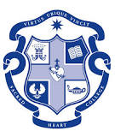
Middle Schooling Philosophy
We believe that curriculum is holistic and generic, which means it encompasses all we do to support the academic, spiritual, social and emotional growth of our students. This is underpinned by strategies employed to cater for the needs of boys and their learning styles and the needs of preadolescent and adolescent students in contemporary society.
Fundamental and contemporary approaches to learning and teaching in Middle Schooling are supported when and where:
- Authentic learning engages students in deep and meaningful learning experiences.
- Learning and teaching processes are constantly constructed and reconstructed to respect the particular needs and circumstances of the learner, with a view to elevating and enhancing their life chances and choices.
- Students not only learn basic skills, but incorporate these skills into tasks requiring complex thinking and in-depth knowledge which is then used to solve problems and create actual products. These products should have value in settings outside the classroom.
- Physical aspects such as timetabling and lesson allocation allow for relationships to develop between teacher and student.
- The teacher utilises information and data collected about how students learn and designs learning experiences and tasks based upon this knowledge. At SHCMS we use a three phase learning style (preliminary, consolidating, culminating) as a framework for lesson task design and structure.
- Higher-order thinking skills are taught so that students are able to ‘manipulate’ information and ideas in ways that transform their meaning and implications. Student talk and engagement are encouraged through the use of significant ideas and questions that facilitate this style of authentic learning.
- Students feel connected to the world beyond the classroom and authentic instruction connects the classroom to some ‘real world public problem’ or personal experiences that the student can relate to.

Successful learners...
- develop their capacity to learn and play an active role in their own learning
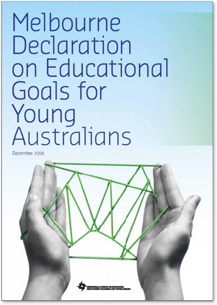
- have the essential skills in literacy and numeracy and are creative and productive users of technology, especially ICT, as a foundation for success in all learning areas
- are able to think deeply and logically, and obtain and evaluate evidence in a disciplined way as the result of studying fundamental disciplines
- are creative, innovative and resourceful, and are able to solve problems in ways that draw upon a range of learning areas and disciplines
- are able to plan activities independently, collaborate, work in teams and communicate ideas
- are able to make sense of their world and think about how things have become the way they are
- are on a pathway towards continued success in further education, training or employment, and acquire the skills to make informed learning and employment decisions throughout their lives
- are motivated to reach their full potential.

